Ex26
import cv2
from google.colab import files
from IPython.display import display, Video
# Upload video
uploaded = files.upload()
input_video = next(iter(uploaded))
# Read video
cap = cv2.VideoCapture(input_video)
fps = cap.get(cv2.CAP_PROP_FPS)
width = int(cap.get(cv2.CAP_PROP_FRAME_WIDTH))
height = int(cap.get(cv2.CAP_PROP_FRAME_HEIGHT))
frames = []
# Store all frames
while True:
ret, frame = cap.read()
if not ret:
break
frames.append(frame)
cap.release()
# Reverse the frames
frames.reverse()
# Create reversed video
output_video = "reversed_video.mp4"
fourcc = cv2.VideoWriter_fourcc(*'mp4v')
out = cv2.VideoWriter(output_video, fourcc, fps, (width, height))
for frame in frames:
out.write(frame)
out.release()
print("Video reversed successfully!")
# Display output
display(Video(output_video, embed=True))
# Download output
files.download(output_video)

- lv_0_20261028183601.mp4(video/mp4) - 3937995 bytes, last modified: 10/28/2026 - 100% done
Saving lv_0_20261028183601.mp4 to lv_0_20261028183601.mp4
Video reversed successfully!

Ex27
import cv2
from google.colab import files
from google.colab.patches import cv2_imshow
# Upload image
uploaded = files.upload()
image_path = next(iter(uploaded))
# Read image
img = cv2.imread(image_path)
# Convert to grayscale
gray = cv2.cvtColor(img, cv2.COLOR_BGR2GRAY)
# Load face detection model
face_cascade = cv2.CascadeClassifier(
cv2.data.haarcascades +
'haarcascade_frontalface_default.xml'
)
# Detect faces
faces = face_cascade.detectMultiScale(
gray,
scaleFactor=1.1,
minNeighbors=5,
minSize=(30, 30)
)
# Draw rectangles around faces
for (x, y, w, h) in faces:
cv2.rectangle(img, (x, y),
(x+w, y+h), (0, 255, 0), 3)
print("Number of faces detected:", len(faces))
# Display result
cv2_imshow(img)

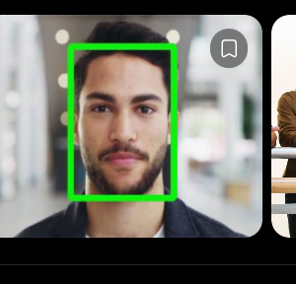

Ex28
import cv2
from google.colab import files
from google.colab.patches import cv2_imshow
from IPython.display import display, Video
# Upload video
uploaded = files.upload()
video_path = next(iter(uploaded))
cap = cv2.VideoCapture(video_path)
fps = cap.get(cv2.CAP_PROP_FPS)
width = int(cap.get(cv2.CAP_PROP_FRAME_WIDTH))
height = int(cap.get(cv2.CAP_PROP_FRAME_HEIGHT))
# Background subtractor
bg_subtractor = cv2.createBackgroundSubtractorMOG2(
history=500,
varThreshold=50
)
output = "vehicle_detection.mp4"

fourcc = cv2.VideoWriter_fourcc(*'mp4v')
out = cv2.VideoWriter(output, fourcc, fps, (width, height))
while True:
ret, frame = cap.read()
if not ret:
break
# Apply background subtraction
mask = bg_subtractor.apply(frame)

# Remove noise
kernel = cv2.getStructuringElement(
cv2.MORPH_RECT, (5, 5)
) mask = cv2.morphologyEx(
mask, cv2.MORPH_OPEN, kernel
) # Find contours
contours, _ = cv2.findContours(
mask,
cv2.RETR_EXTERNAL,
cv2.CHAIN_APPROX_SIMPLE
) count = 0
for contour in contours:
area = cv2.contourArea(contour)
if area > 1000:
x, y, w, h = cv2.boundingRect(contour)
cv2.rectangle(
frame, (x, y),
(x+w, y+h), (0, 255, 0), 2
)
cv2.putText(
frame, "Vehicle",
(x, y-10),
cv2.FONT_HERSHEY_SIMPLEX,
0.7, (0, 0, 255), 2
) count += 1
cv2.putText(
frame, "Vehicles: " + str(count),
(20, 40),
cv2.FONT_HERSHEY_SIMPLEX,
1, (255, 0, 0), 2
)
out.write(frame)
cap.release()
out.release()
print("Vehicle detection completed!")
display(Video(output, embed=True))
files.download(output)
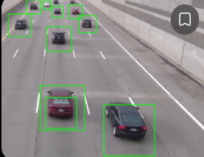

Ex29
import cv2
from google.colab import files
from google.colab.patches import cv2_imshow
uploaded = files.upload()
image_path = next(iter(uploaded))
img = cv2.imread(image_path)
gray = cv2.cvtColor(img, cv2.COLOR_BGR2GRAY)

eye_cascade = cv2.CascadeClassifier(
cv2.data.haarcascades +
'haarcascade_eye.xml'
)eyes = eye_cascade.detectMultiScale(
gray,
scaleFactor=1.1,
minNeighbors=5,
minSize=(20, 20)
)for (x, y, w, h) in eyes:
cv2.rectangle(
img, (x, y),
(x+w, y+h), (0, 255, 0), 2
)print("Number of eyes detected:", len(eyes))
cv2_imshow(img)
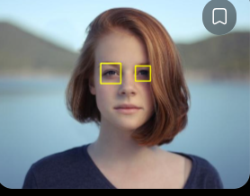

Ex30
import cv2
from google.colab import files
from google.colab.patches import cv2_imshow
uploaded = files.upload()
image_path = next(iter(uploaded))
img = cv2.imread(image_path)
gray = cv2.cvtColor(img, cv2.COLOR_BGR2GRAY)
smile_cascade = cv2.CascadeClassifier(
cv2.data.haarcascades +
'haarcascade_smile.xml'
)smiles = smile_cascade.detectMultiScale(
gray,
scaleFactor=1.7,
minNeighbors=20,
minSize=(25, 25)
)
for (x, y, w, h) in smiles:
cv2.rectangle(
img, (x, y),
(x+w, y+h), (0, 255, 0), 2
)print("Number of smiles detected:", len(smiles))
cv2_imshow(img)

